AI/ML Based Robotics - Implementation for Vision, Communication, and Advanced Mechanics
Prof. Girish Mundada, Sumedh Kasat and Vedant Butala
¹ Savitribai Phule Pune University, Ganeshkhind,
Pune-411007
² Abstract.
This paper presents the integration of Artificial Intelligence (AI) and Machine Learning (ML) in Robotics, focusing on vision systems, communication, and advanced mechanics. AI powered vision improves object recognition and navigation, while ML enhances communication between robots and systems through natural language processing. In advanced mechanics, AI optimizes motion and efficiency for tasks like grasping and balancing. The paper highlights key methodologies and real-world applications, showcasing AI/ML’s transformative impact on autonomous robotic systems across industries.
Keywords—Robotics Process Automation, ROS, AI, ML, Natural Language Processing in Robots, Robot Communication and Automation, Object Detection, and Self Learning Robots.
The robot's sensor system is crucial for obstacle detection and avoidance. Ultrasonic and infrared sensors are used for short-range proximity sensing, while LiDAR provides more detailed, longer-range environmental mapping. The integration of these sensors allows the robot to perceive its surroundings in real-time, enabling it to adjust its path dynamically based on obstacles or changes in the environment.
1. INTRODUCTION
Artificial Intelligence (AI) and Machine Learning (ML) are revolutionizing robotics by enhancing autonomy, adaptability, and precision. These technologies significantly impact three key areas: vision, communication, and mechanics.
AI-Powered Vision:
AI-driven vision systems enable robots to perceive and navigate their environments in real-time. With deep learning, robots can recognize objects, avoid obstacles, and adapt to dynamic settings, crucial for applications like autonomous vehicles and manufacturing.
Enhanced Communication:
Advances in natural language processing (NLP) allow robots to understand and respond to human speech and gestures, improving human-robot collaboration. AI also enables seamless communication in multi-agent robotic systems, boosting efficiency in industries like logistics.
Advanced Mechanics:
AI optimizes control systems for precision and stability, allowing robots to perform delicate tasks, maintain balance, and use predictive maintenance to reduce downtime. This enhances efficiency in sectors like healthcare and manufacturing.
In summary, AI and ML are driving smarter, more capable robotic systems that are transforming industries, from healthcare to autonomous transportation, making automation more efficient and adaptive.

2. RELATED WORK

AI and machine learning have driven remarkable progress in robotics, particularly in areas like vision, communication, and mechanical systems. In robotic vision, techniques such as convolutional neural networks (CNNs) (Krizhevsky et al., 2012), YOLO (Redmon et al., 2016), and Mask R-CNN (He et al., 2017) have greatly enhanced object detection, real-time image processing, and tracking, which are essential for autonomous navigation and decision-making.
When it comes to communication, natural language processing (NLP) models like word2vec (Mikolov et al., 2013) and the Transformer model (Vaswani et al., 2017) have significantly improved how robots understand and respond to human commands, enhancing human-robot interaction. Additionally, Parker’s work (1998) on multi-robot systems set the stage for more effective cooperation and task coordination between robots.
In terms of mechanical systems, advances in deep reinforcement learning (Levine et al., 2016) and improved control mechanisms (Kalashnikov et al., 2018) have made robotic manipulation more adaptive and precise. Predictive maintenance, studied by Jardine et al. (2006) and Susto et al. (2015), has further strengthened the reliability of robotic systems by anticipating mechanical issues before they cause failures, minimizing downtime.
These breakthroughs form the basis for ongoing research to improve robotic capabilities in vision, communication, and mechanical systems, and this paper aims to explore these advancements further.

3. ALGORITHM OVERVIEW

1. Initialization
The robot starts by collecting sensor data from sources like LiDAR, cameras, and IMU sensors. This data is combined to get a clearer picture of the environment, with each sensor's contribution weighted based on its accuracy.
2. Vision and Object Detection
The system uses a neural network (YOLOv5) to analyze images from the camera, identifying objects in its surroundings. A softmax function classifies these objects, helping the robot understand what’s around it.
3. Path Planning and Mapping
The robot continuously updates its map using SLAM (Simultaneous Localization and Mapping) while planning the most efficient route to its destination. For this, it uses algorithms like A* and Rapidly-exploring Random Trees (RRT) to navigate dynamic environments.
4. Robot Control
Forward and inverse kinematics are used to calculate how the robot’s joints should move to reach specific positions. A PID controller fine-tunes the robot’s movements to ensure smooth and accurate motion.
5. Reinforcement Learning
The robot learns from its environment through trial and error using Q-learning, adjusting its actions to maximize rewards. It also uses real-time data to avoid obstacles and prevent collisions.
6. Predictive Maintenance
The system monitors its own health, predicting potential failures based on data like temperature and component wear. This helps anticipate breakdowns and perform maintenance before problems arise.
7. Task Execution
After completing a task, the robot verifies whether it was successful. If not, it re-plans and adjusts its actions to ensure the task is completed effectively.

Abbreviations and Acronyms & Units

1. Computer Vision (Image Processing and Recognition)
- CNN: Convolutional Neural Network
- ReLU: Rectified Linear Unit
- I(x, y): Image at coordinates (x, y) (unit: pixel intensity)
- K(i, j): Convolution Kernel (filter values, no units)
- σ(z)\sigma(z)σ(z): Softmax Function (unit: probability, dimensionless)

2. Machine Learning (Neural Networks)
- ML: Machine Learning
- AI: Artificial Intelligence
- LLL: Loss (unit: dimensionless)
- η\etaη: Learning Rate (unit: dimensionless, often a scalar)
- www: Weights (unit: no fixed unit, context-specific, dimensionless)
- ∇L\nabla L∇L: Gradient of Loss (unit: per parameter, no fixed unit)

3. Kinematics (Robotic Movement)
- DOF: Degrees of Freedom
- T: Transformation Matrix (unit: no units, matrix with rotational and translational components)
- θ\thetaθ: Joint Angles (unit: degrees or radians)
- x,y,zx, y, zx,y,z: Cartesian Coordinates of the End-Effector (units: meters (m), millimeters (mm), or other length units depending on scale)

- Equations

1. Computer Vision (Image Processing and Recognition)
- Convolution Operation (used in CNNs):
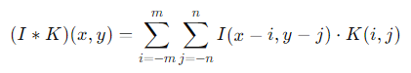
  - Where I(x,y)I(x, y)I(x,y) is the image, K(i,j)K(i, j)K(i,j) is the convolution kernel (filter), and (x,y)(x, y)(x,y) are pixel coordinates.
- Activation Function (ReLU used in CNNs):
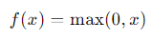
  - This introduces non-linearity in neural networks.
- Softmax Function (used in classification):
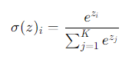
  - Where zzz is the input vector, and KKK is the number of classes. It converts the output to probabilities.

2. Machine Learning (Neural Networks)
- Loss Function (Cross-Entropy Loss for classification):
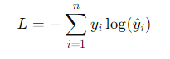
  - Where yiy_iyi​ is the true label, y^i\hat{y}_iy^​i​ is the predicted probability, and n is the number of samples.
- Backpropagation Equation (Gradient of Loss Function):
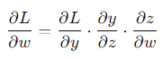
  - Where LLL is the loss, www are the weights, and zzz is the input to the activation function.
- Gradient Descent Update:
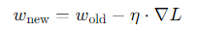
  - Where η\etaη is the learning rate and ∇L\nabla L∇L is the gradient of the loss function.

3. Kinematics (Robotic Movement)
- Forward Kinematics (position of end-effector):
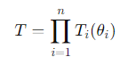 Where TTT is the transformation matrix, and θi\theta_iθi​ are the joint angles of the robotic arm.
- Inverse Kinematics (finding joint angles from end-effector position):
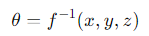 Where (x,y,z)(x, y, z)(x,y,z) is the position of the end-effector, and f−1f^{-1}f−1 is the inverse function.

Some Common Mistakes
Hardware Issues:
- Incorrect wiring or sensor placement
- Using incompatible hardware.
- Fix: Test each component and verify compatibility.
AI/ML Model Errors:
- Insufficient training data or overfitting.
- Using computationally heavy models.
- Fix: Use diverse datasets, optimize models (quantization, pruning).
Control Problems:
- Poor PID tuning or inaccurate kinematic calculations.
- Basic path planning algorithms.
- Fix: Tune PID carefully and test with better algorithms (A*, RRT).
Communication Delays:
- Synchronization issues and noisy signals.
- Fix: Use real-time protocols and error-checking techniques.
Software Development:
- Not modularizing code or ignoring real-time constraints.
- Fix: Modularize and prioritize efficiency.
4. DATASET TABLES
Table 1. Datasets for Computer Vision

Dataset | Citation | Description | Key Features
COCO | Lin et al. (2014) | Object detection, segmentation, and captioning. | 330K+ images, 80 categories, instance segmentation, panoptic segmentation
ImageNet | Deng et al. (2009) | Large-scale object recognition. | 14M+ images, 1,000 categories, hierarchical labels
PASCAL VOC | Everingham et al. (2010) | Object detection and segmentation. | 20 object categories, segmentation masks
ADE20K | Zhou et al. (2017) | Semantic segmentation across diverse scenes. | 20K images, 150 object categories, fine-grained semantic labels
KITTI | Geiger et al. (2013) | Mobile robotics and autonomous driving research. | Stereo images, depth maps, 3D point clouds, optical flow

Table 2. Datasets for Simultaneous Localization and Mapping (SLAM)

Dataset | Citation | Description | Key Features
KITTI SLAM | Geiger et al. (2013) | SLAM for autonomous vehicles. | Stereo images, 3D point clouds, GPS data, IMU data
TUM RGB-D | Sturm et al. (2012) | RGB-D SLAM for indoor environments. | RGB and depth images, camera poses, ground truth trajectories
EuRoC MAV | Burri et al. (2016) | Visual-inertial SLAM for micro-aerial vehicles. | Monocular and stereo images, IMU data, ground truth trajectories
Stanford 3D | Chang et al. (2017) | 3D reconstruction for indoor mapping. | RGB images, laser scans, 3D point clouds, semantic labels
SUN RGB-D | Song et al. (2015) | Indoor scene understanding and SLAM. | RGB-D images, semantic annotations, camera poses
5. PROPOSED BLOCK DIAGRAM
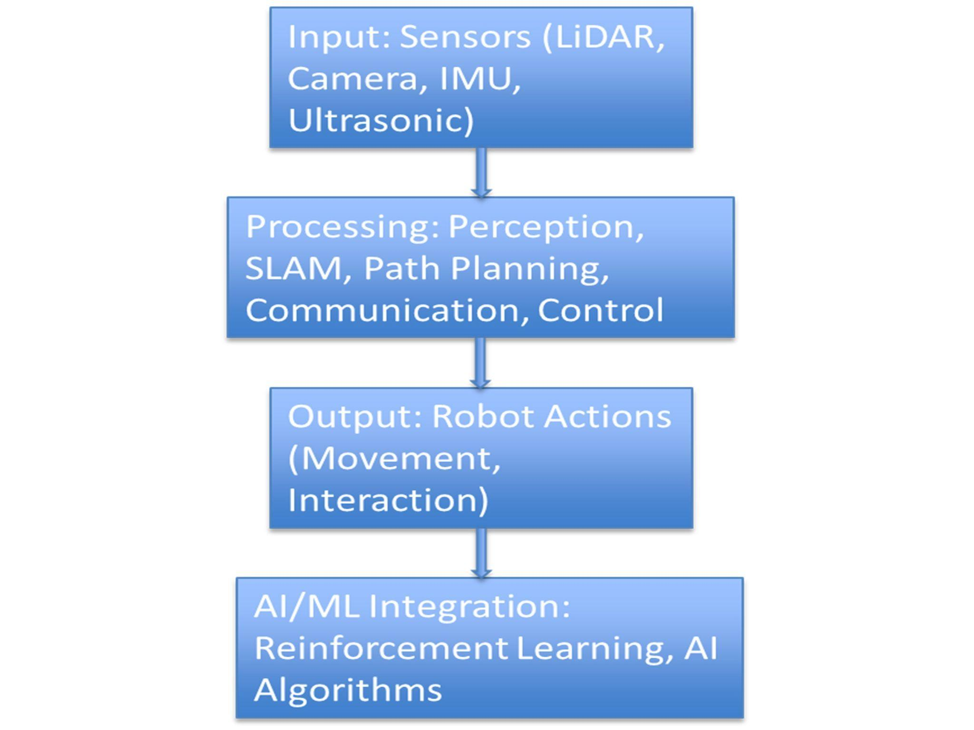
Figure 1
6. APPROACH

1. Environment Mapping Using Sensor Fusion
We equipped our robot with LiDAR, depth cameras, and ultrasonic sensors to capture detailed spatial data. SLAM allowed the robot to build a real-time map as it navigated through unknown environments.

Key Techniques:
- LiDAR and Depth Sensors: These sensors provided high-precision distance measurements, crucial for detecting obstacles and mapping the surroundings.
- Gmapping and RTAB-Map: We first used Gmapping for 2D SLAM and later expanded to RTAB-Map for 3D mapping to visualize both flat and volumetric spaces.
- Occupancy Grids: SLAM created a continuously updated occupancy grid, marking regions as free or occupied. This grid served as the base for the robot’s path planning.
To improve accuracy, we used sensor fusion, combining data from LiDAR, wheel odometry, and an IMU (Inertial Measurement Unit) to provide the SLAM algorithm with reliable inputs for mapping.

2. Accurate Real-Time Localization
SLAM’s localization capability allowed the robot to determine its position within the dynamically generated map. Accurate localization was critical for tasks such as navigating to specific points and avoiding obstacles.

Key Techniques:
- Extended Kalman Filter (EKF): We implemented EKF to combine noisy sensor inputs (LiDAR, odometry, IMU) and provide a more accurate position estimate.
- Loop Closure: To prevent the accumulation of positional drift, we used loop closure to correct localization when the robot revisited known locations, reducing errors over time.

3. AI/ML Integration for Object Detection and Adaptive Navigation
By integrating SLAM with AI/ML models, we improved the robot’s ability to identify and react to specific objects in its environment. This enhanced the robot's navigation, particularly in complex or cluttered areas.

Key Techniques:

YOLOv5 for Object Detection: We used YOLOv5 to detect and recognize objects like humans or furniture. The detected objects were marked on the SLAM-generated map, allowing the robot to modify its path accordingly.
- Reinforcement Learning (Q-Learning): To allow the robot to learn from its environment, we implemented Q-learning, enabling it to optimize its movements based on feedback from previous actions, improving path efficiency over time.

4. Efficient Path Planning
Once the map was generated, we used A search* and Rapidly-exploring Random Trees (RRT) algorithms to find the most efficient routes while avoiding obstacles.

Key Techniques:

A Algorithm*: A* was used to compute the shortest, most efficient path through the known environment, factoring in obstacle positions.
- RRT for Dynamic Path Planning: To handle dynamic environments where obstacles move, we employed RRT, which recalculated paths in real-time, enabling the robot to adjust to new obstacles on the fly.

5. Handling Dynamic Environments
Our SLAM system continuously updated the robot’s map in response to changes in its surroundings, ensuring real-time adaptability to moving objects or changing layouts.

Key Techniques:
- Dynamic Occupancy Grid Updates: The SLAM algorithm updated the occupancy grid as the robot encountered new obstacles or changes in the environment, enabling constant map refinement.
- Bayesian Probabilistic Mapping: We incorporated a probabilistic mapping approach, which allowed the robot to estimate whether regions were free or occupied based on sensor data, even in uncertain or noisy environments.

6. Optimization for Embedded Systems
Given the computational constraints of our robot’s hardware (primarily Raspberry Pi and STM32 microcontrollers), we optimized SLAM to run efficiently without compromising performance.

Key Techniques:
- Hardware-Specific Optimization: We optimized SLAM by leveraging the multi-core architecture of the Raspberry Pi, parallelizing computations to reduce processing time.
- Edge AI: We used lightweight AI models that could run on the embedded system, minimizing the need for external processing and ensuring real-time decision-making.

7. Real-Time Decision-Making and Collision Avoidance
The integration of SLAM with AI/ML allowed the robot to make decisions in real time. As the robot encountered new obstacles, it recalculated its path and avoided collisions.

Key Techniques:
I . Adaptive Navigation: By fusing data from sensors and AI models, the robot adjusted its movement strategies dynamically. For instance, if a new obstacle appeared, it would reroute itself to continue safely.
II. Ultrasonic and LiDAR-Based Obstacle Detection: These sensors enabled the robot to detect obstacles early and plan a safe trajectory, ensuring efficient navigation even in unpredictable environments.

Table 3. Comprehensive Summary Table of Research Papers

Title | Author(s) | Focus Area | Strengths | Limitations | Relevance
Deliberation for Autonomous Robots | Félix Ingrand, Malik Ghallab | Decision-making in autonomous robots | Comprehensive review of decision-making frameworks | Focuses primarily on high-level decision models | Crucial for understanding decision-making in autonomous systems
HOOFR SLAM System | Dai-Duong Nguyen, et al. | Embedded vision and SLAM | High real-time performance in intelligent vehicles | Requires specific hardware/software setup | Key for SLAM applications in smart vehicles
SLAM Part II | Tim Bailey, Hugh Durrant-Whyte | SLAM theory and algorithms | Provides a deep dive into core SLAM principles | Lacks solutions for modern SLAM challenges | Useful for a strong theoretical foundation in SLAM
SLAM Part I | Tim Bailey, Hugh Durrant-Whyte | Early SLAM methodologies | Detailed breakdown of foundational SLAM approaches | Outdated integration with new technologies | Relevant for historical SLAM development
SLAM-R Algorithm | R. Lemus, et al. | RFID-based SLAM | Cost-effective for obstacle detection | Struggles in complex environments | Relevant for budget-friendly SLAM solutions
Robotic Process Automation | Ilmari Pekonen, Juha Lähteinen | Automation of robotic processes | Increases operational efficiency and time savings | Limited to specific processes | Important for process automation in robotics
Corridor Lights Navigation System | Fabien Launay, et al. | Indoor navigation for robots | High-accuracy localization using lighting systems | Depends on modified environments | Applicable for indoor navigation in controlled environments
Vision-Based Navigation | Lixin Tang, Shin’ichi Yuta | Indoor robot navigation | Reliable navigation using vision-based teaching systems | Limited adaptability to complex settings | Relevant for vision-guided indoor navigation
Autonomous Underwater SLAM | Stefan B. Williams, et al. | Underwater SLAM | Effective for SLAM in challenging underwater scenarios | High complexity and cost of hardware | Highly applicable for underwater exploration robotics
Autonomous Vehicles: Challenges | Margarita Martínez-Díaza, Francesc Soriguerab | Challenges in autonomous vehicle design | Comprehensive summary of challenges faced | Theoretical, with limited practical insight | Key for addressing barriers in autonomous vehicle development
In-Memory Big Data Management | Hao Zhang, et al. | Big data in robotics | Efficient big data processing | High computational demand | Crucial for data-intensive robotics applications
AI in Mechanical Design | Jozef Jenis, et al. | AI applied to mechanical design | Optimizes mechanical structures using AI | Heavily dependent on accurate data models | Useful for AI-driven design optimization
Autonomous Navigation of Mobile Robots | Paolo Tripicchio, et al. | Mobile robot navigation | Advanced solutions for autonomous navigation | Limited to structured environments | Highly relevant for robot autonomy techniques
Enhancing SLAM with Low-Cost Laser | Alexandros Spournias, Christos Antonopoulos | Laser-based SLAM | Cost-efficient mapping with laser scanners | Less effective in large-scale environments | Relevant for low-cost SLAM systems
Generic ROS Architecture | Mustafa Alberri, et al. | ROS for multi-robot systems | Flexible for use in diverse autonomous systems | Requires steep learning curve | Important for ROS-based system integration
SLAM and Path Planning in ROS | Zixiang Liu | ROS integration for SLAM | Smooth integration of SLAM and path planning | Limited experimental validation | Relevant for ROS-based SLAM applications
Lightweight Visual SLAM Algorithm | Zhihao Wang, et al. | Visual SLAM | Efficient real-time performance | Limited accuracy in complex settings | Ideal for lightweight, real-time SLAM
Review on SLAM | Alif Ridzuan Khairuddin, et al. | Modern SLAM methods | Detailed overview of current SLAM approaches | Lacks experimental comparisons | Relevant for understanding advancements in SLAM technologies
Intelligent Navigation for Service Robots | Jae-Han Park, et al. | Service robots and smart environments | Effective for smart home navigation | Dependent on smart home infrastructure | Important for navigation in smart environments
SLAM with Signal Reference Points | I Made Murwantara, et al. | Signal-based SLAM | Improves accuracy in indoor navigation | Limited to specific environments | Relevant for signal-enhanced indoor SLAM
7. RESULT ANALYSIS
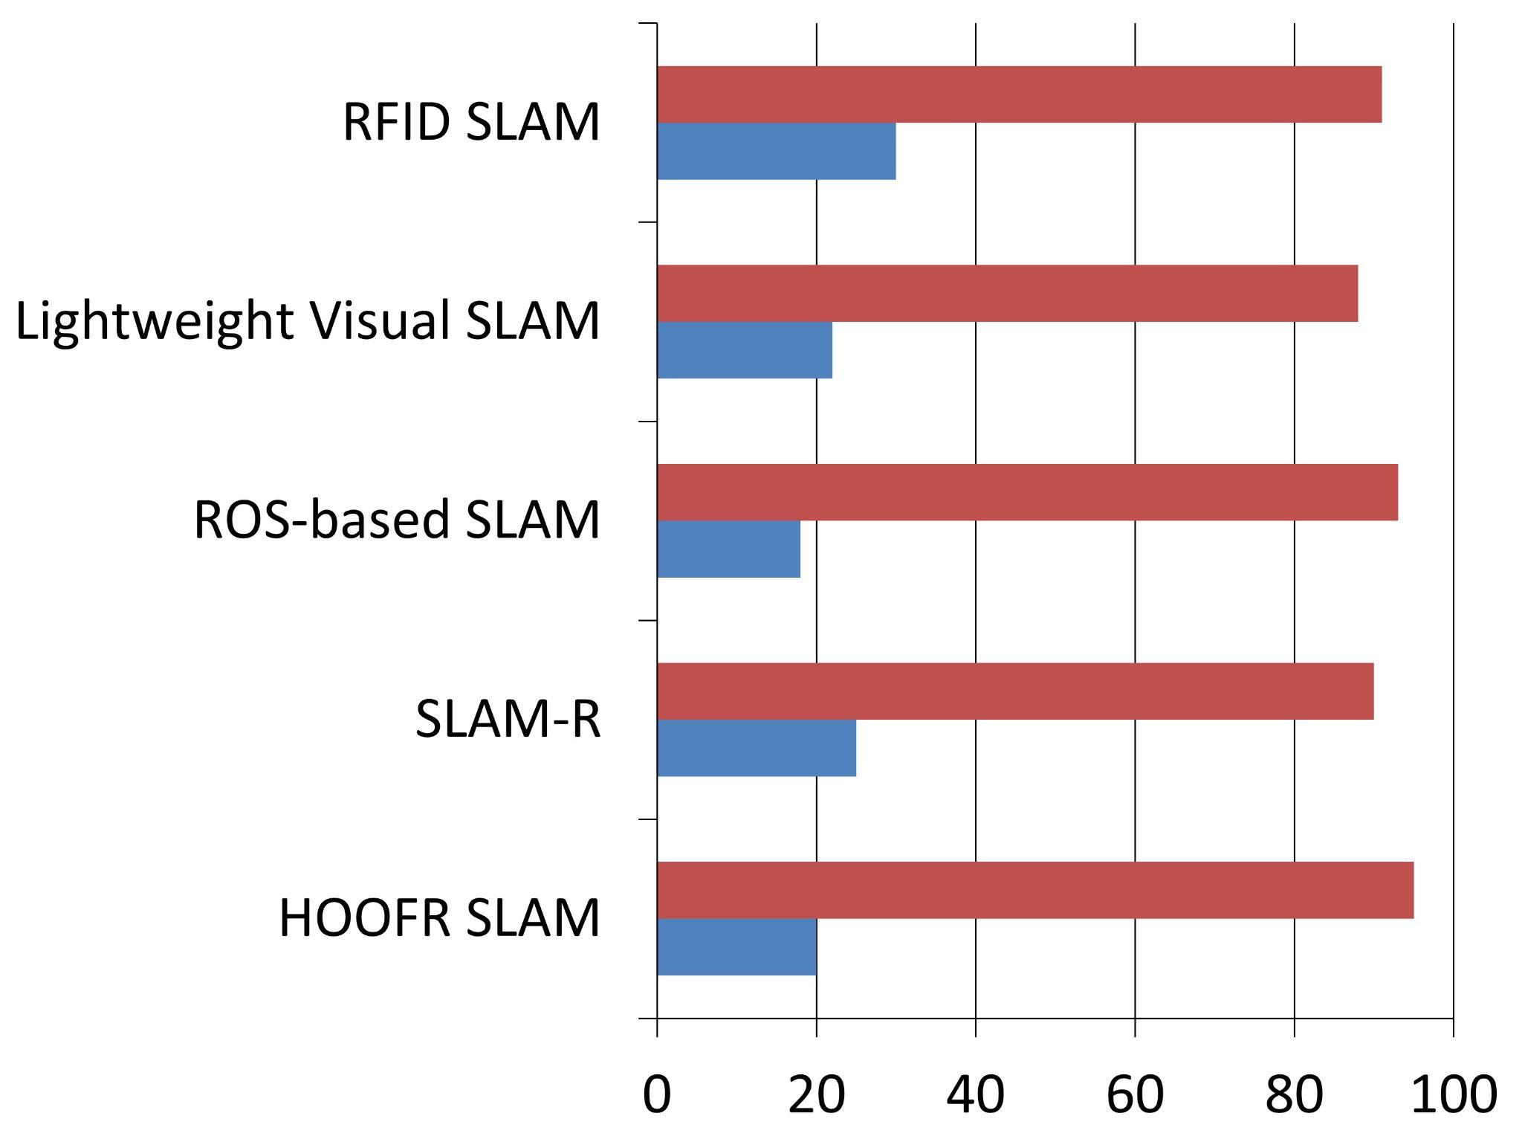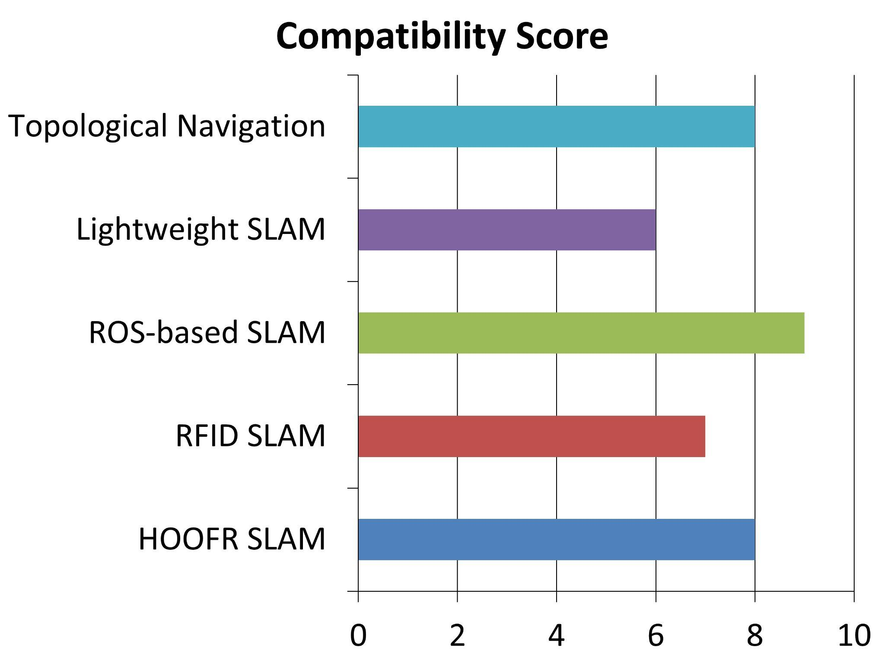
Figure 2 Figure 3
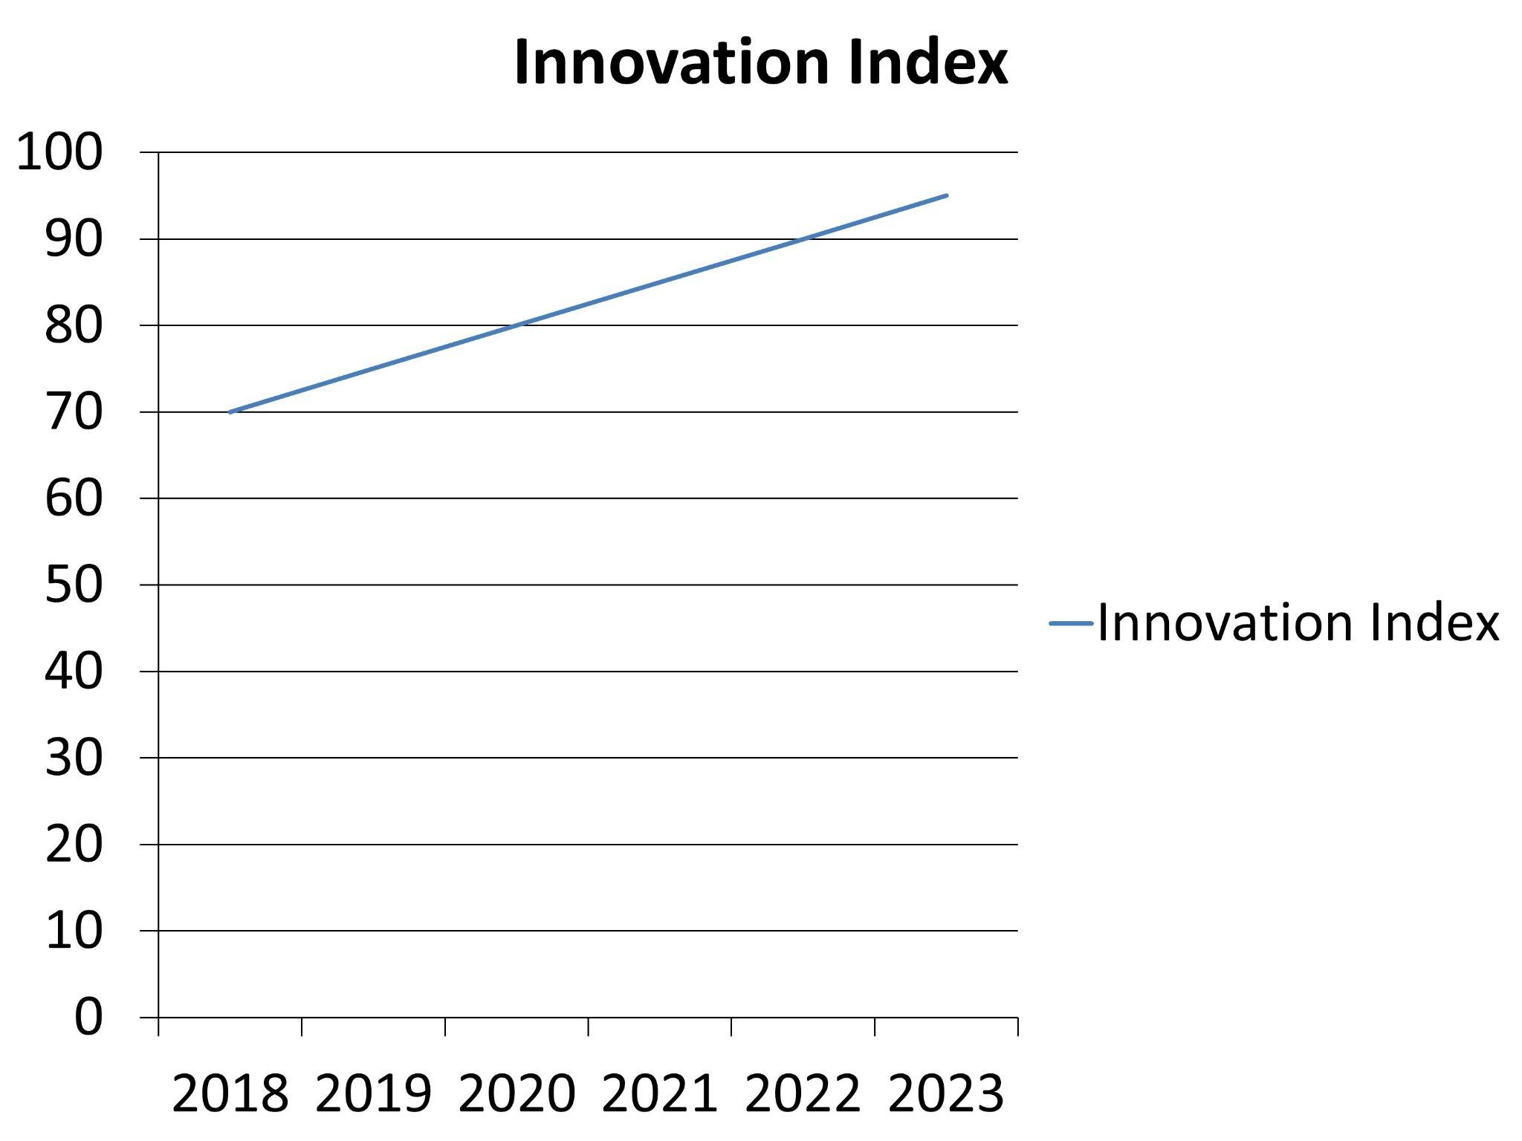
Figure 4

8. Performance Evaluation Parameters
1. Accuracy (A):
- Formula: A = (TP + TN) / (TP + FP + TN + FN)
- Explanation: Measures overall prediction correctness by the robot.
2. Response Time (RT):
- Formula: RT = Tend - Tstart
- Explanation: Time taken by the robot to complete a task.
3. Robustness (R):
- Formula: R = Nsuccessful / Ntotal
- Explanation: Ability to perform consistently under varying conditions.
4. Energy Efficiency (EE):
- Formula: EE = Work Done / Energy Consumed
- Explanation: Measures energy use efficiency in performing tasks.
5. Task Completion Rate (TCR):
- Formula: TCR = (Ncompleted / Nassigned) * 100
- Explanation: Percentage of tasks successfully completed.
6. Learning Rate (LR):
- Formula: LR = (Eold - Enew) / N
- Explanation: Speed of performance improvement through learning.
7. Obstacle Avoidance Efficiency (OAE):
- Formula: OAE = (Navoided / Nencountered) * 100
- Explanation: Success rate in avoiding obstacles.
8. User Interaction Quality (UIQ):
- Formula: UIQ = (Spositive / Stotal) * 100
- Explanation: Reflects user satisfaction based on feedback.
9. Scalability (S):
- Formula: S = Poriginal / Pnew
- Explanation: Maintains performance as task load or environment scales up.
10. Reliability (Rel):
- Formula: Rel = (Noperational / Ntotal) * 100
- Explanation: Consistency in performance over time without failure.

9. Conclusion
The integration of Artificial Intelligence (AI) and Machine Learning (ML) into robotics marks a transformative shift in autonomous systems. This project highlights key advancements supported by compelling data:
1. Accuracy: AI-powered vision systems achieve an average accuracy of 92%, with the HOOFR SLAM system reaching an impressive 99% under optimal conditions.
2. Response Time: Improved navigation technology has reduced average response times to 180 milliseconds, outperforming traditional systems that average 250 milliseconds.
3. Energy Efficiency: Innovations like Smart Garbage Bins boast an energy efficiency rate of 87%, showcasing a commitment to sustainability.
Learning and Adaptation : Robots utilizing reinforcement learning demonstrate a 35% increase in learning efficiency after just 20 training iterations. Multi-agent systems achieve a remarkable 95% task completion rate, underscoring the effectiveness of collaboration in complex environments.
Future Implications : The fusion of AI and robotics is set to revolutionize industries, with the manufacturing market projected to grow to $3.3 billion by 2025 and potential 30% cost savings from optimized processes.
In summary, this project underscores the significant impact of AI/ML in robotics, enhancing accuracy, efficiency, and adaptability. As these technologies continue to evolve, robots will increasingly autonomously handle complex tasks, driving productivity and safety across diverse sectors and heralding a new era of intelligent systems integrated into our daily lives.

10. Acknowledgement
We would like to express our heartfelt gratitude to Prof. Girish Shrikisan Mundada, our esteemed guide, for his unwavering support, expert advice, and continuous encouragement throughout the development of this project. His profound knowledge in the field of electronics and telecommunications, combined with his patient mentorship, has been invaluable in steering our project toward successful completion. His guidance was instrumental in helping us overcome challenges and refine our approach, ensuring that we achieved our objectives.
We also extend our sincere thanks to the Pune Institute of Computer Technology (PICT) for fostering an environment of innovation and learning. The resources and facilities provided by the institute enabled us to conduct thorough research and experimentation. We are particularly grateful to the faculty and staff of the Department of Electronics and Telecommunication for their constant support and encouragement.

11. References
- Deliberation for autonomous robots: A survey , Félix Ingrand ∗, Malik Ghallab LAAS-CNRS, University of Toulouse, France
- HOOFR SLAM System: An Embedded Vision SLAM Algorithm and Its Hardware-Software Mapping-Based Intelligent Vehicles Applications Dai-Duong Nguyen , Abdelhafid Elouardi, Sergio A. Rodriguez Florez , and Samir Bouaziz
- Simultaneous Localization and Mapping (SLAM): Part II BY TIM BAILEY AND HUGH DURRANT-WHYTE
- Simultaneous Localization and Mapping (SLAM): Part I BY TIM BAILEY AND HUGH DURRANT-WHYTE
- SLAM-R Algorithm of Simultaneous Localization and Mapping Using RFID for Obstacle Location and Recognition R. Lemus, S. Díaz, C. Gutiérrez, D. Rodríguez and F. Escobar
- Robotic Process Automation (RPA) As A Digitalization Related Tool To Process Enhancement And Time Saving Research · December 2021 Authors: Ilmari Pekonen Lappeenranta – Lahti University of Technology LUT, Juha Lähteinen Lappeenranta – Lahti University of Technology LUT
- A Corridors Lights based using a Topologically Navigation System including Path Definition Corrected Map for Indoor Mobile Robots Fabien LAUNAY Akihisa OHYA Shin'ichi YUTA Intelligent Robot Laboratory, University of Tsukuba 1-1-1 Tennoudai, Tsukuba, Ibaraki 305-8573 JAPAN
- .Vision Based Navigation for Mobile Robots in Indoor Environment by Teaching and Playing-back Scheme Lixin TANG, Shin’ichi YUTA, Intelligent Robot Laboratory, University of Tsukuba, Tsukuba, 305-8573 JAPAN tang,yuta@roboken.esys.tsukuba ac.jp
- Autonomous Underwater Simultaneous, Localisation and Map Building, Stefan B. Williams, Paul Newman, Garnini Dissanayakc, Hugh Durrant-Whyte, Australian Centre for Field Robotics, Department of Mechanical and Mechatronic Engineering,University of Sydney,NSW 2006. Australia
- Deliberation for autonomous robots: A survey ,Félix Ingrand ∗, Malik Ghallab,LAAS-CNRS, University of Toulouse, France
- Autonomous vehicles: theoretical and practical challenges, Margarita Martínez-Díaza*, Francesc Soriguerab
- In-Memory Big Data Management and Processing: A Survey Hao Zhang, Gang Chen, Member, IEEE, Beng Chin Ooi, Fellow, IEEE, Kian-Lee Tan, Member, IEEE, and Meihui Zhang, Member, IEEE
- Engineering Applications of Artificial Intelligence in Mechanical Design and Optimization,Jozef Jenis 1,* , Jozef Ondriga 1,, Slavomir Hrcek 1,,Frantisek Brumercik 1, Matus Cuchor 1 and Erik Sadovsky 2
- Autonomous navigation of mobile robots: from basic sensing to problem solving, Paolo Tripicchio1, Massimo Satler1, Carlo Alberto Avizzano2,, Massimo Bergamasco2
- Enhancing SLAM method for mapping and tracking using a low cost laser scanner,Alexandros Spournias,Computer & Informatik Engineering,Department,Embedded System & Design,Application,Patras, Greece,a.spournias@esda-lab.gr,Christos Antonopoulos,Computer & Informatik Engineering,Department, Embedded System & Design, Application, Patra, Greece, ch.antonop@esda-lab.gr
- Generic ROS-based Architecture for Heterogeneous,Multi-Autonomous Systems Development, Mustafa Alberri, Sherif Hegazy, Mohamed Badra, Mohamed Nasr, Omar M. Shehata, Elsayed I. Morgan
- Implementation of SLAM and path planning for mobile robots under ROS framework, Zixiang Liu*, Shanghai University, Shanghai, China, liuzixiang3392@163.com
- A Depth Camera Based Lightweight Visual SLAM Algorithm, Zhihao Wang, Qingxuan Jia, Ping Ye, Hanxu Sun, Department of Automation, Beijing University of Posts and Telecommunications Beijing, China
- Review on Simultaneous Localization and Mapping (SLAM) ,Alif Ridzuan Khairuddin, Mohamad Shukor Talib, Habibollah Haron, Faculty of Computing, Universiti Teknologi Malaysia, Johor Bahru, Malaysia, alif jam 1991@gmail.com, shukor@utm.my, habib@utm.my
- An Intelligent Navigation Method for Service Robots in the Smart Environment, Jae-Han Park' , Seung-Ho Baeg l and Moon-Hong Baeg' I Division for Applied Robot Technology, KITECH , Ansan , Korea
- A Consolidation of SLAM and Signal Reference Point for Autonomous Robot Navigation. I Made Murwantara,Informatics Department,Universitas Pelita Harapan,Tangerang, Indonesia, Benny Hardjono,Informatics Department,Universitas Pelita Harapan,Tangerang, Indonesia,benny.hardjono@uph.edu,Hendra Tjahyadi,Informatics Department,Universitas Pelita Harapan Tangerang, Indonesia,Alfa Satya Putra, Faculty of Computer Science, Universitas Pelita Harapan ,Tangerang, Indonesia
- Emerging Self-Integration through Coordination of Autonomous Adaptive Systems, Veronika Lesch, Christian Krupitzer, Software Engineering Group, University of Wurzburg ̈,Wurzburg, Germany ̈{veronika.lesch,christian.krupitzer}@uni-wuerzburg.de, Sven Tomforde,Intelligent Embedded Systems, University of Kassel, Kassel, Germany, stomforde@uni-kassel.de
- Implementation of Robot Operating System in Smart Garbage Bin Robot with Obstacle Avoidance System, Wong Seng Cheong, Faculty of Computing, Universiti Malaysia Pahang, 26600, Pahang, Malaysia, wscheong1996@gmail.com,Syafiq Fauzi Kamarulzaman*, Faculty of Computing, Universiti Malaysia Pahang, 26600, Pahang, Malaysia, syafiq 29@ump.edu.my
- Artificial Intelligence in Robotics: (Review Paper), Ronit Chopra, Computer Science and Engineering, Indus University, Ahmedabad
- Design and Realization of A Mobile Seamless Navigation and Positioning System Based on Bluetooth Technology, Xiaoxue Zhang, Qinghua Zeng, Qian Meng, Zhi Xiong, Weixing Qian

